Create to Learn Companion Web Site
https://createtolearn.online/
- Go to the Create to Learn website and sign in.
- Click on tab, Student Study Materials
- Select the chapter that you are reading, and view the slide show. Follow your interests in relation to using other resources that are provided.

Reading Guide

Week 5: Chapter 4 (complete before class on 2/13)
Chapter 4 Accessing and Analyzing Ideas
After reading the chapter, please view the Accessing and Analyzing slide deck on the student resources section of the Create to Learn companion website. Then, complete the three items below (slide 18,
- Slide 18 Media literacy perspective for analyzing texts

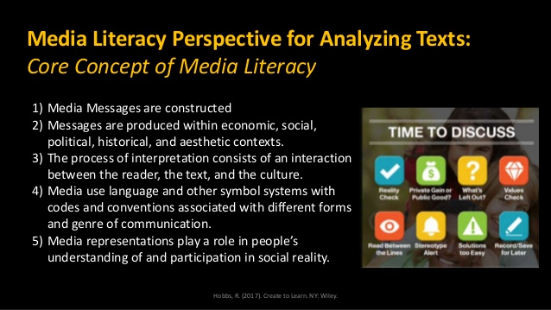

The classic Rand Reading Study Group (2003) report represents reading comprehension as an interaction of reader, text, and activity, situated in a socio-cultural context. Picture 3 interconnecting circles, inside a larger circle!
Here, Hobbs suggests media literacy interpretation consists of an interaction of reader, text, and culture.
With regard to the RRSG reading comprehension framework:
When we think of reader factors in relation to reading comprehension, we might consider the reader’s interests, background knowledge about the topic, prior measures of reading achievement, languages spoken, etc. We consider text factors such as concepts and vocabulary, genre, length, format, etc. And, activity is considered in relation to what we ask the reader to do – are they reading to be entertained, to learn something new, how much time do they have and in what ways are they going to express themselves? Finally, the situated nature of literacy is essential to understanding how readers make meaning in a particular context. Reading the back of the detergent box when deciding whether to purchase this brand is very different from reading it when your pet has eaten one of the pods. Further, reading when your friends like to read is different from reading when none of your friends do. In the first case, you may talk about books and share recommendations; in the latter case, you might keep your reading to yourself and not share it.
The above is probably familiar to you, as a reading teacher; now consider Hobbs’ suggested framework for media literacy interpretation as an interaction of reader, text, and culture.
With regard to media literacy…complete the following table of reading, text, and cultural factors, providing an example or two for each factor.
Media Literacy Interpretation
- Reader factors
- Text factors
- Cultural factors
- What else would you add? Is activity an important factor?
- If you were explaining to a student how reading comprehension and media literacy interpretation is similar and different, what would you say?

- Slide 19. Video of student’s critique of Madison’s make-up tutorial
The college student critiques 5 year-old Madison’s make-up tutorial in this screencast (she narrates over the original video, adding some addition screens, as well). She uses the 5 media literacy questions presented in slide 20 (below) to frame her critique. Respond in the table below.
- What was your reaction to Madison’s video?

- Is there anything that you would like to add to the student’s critique (both positive and negative)?

OPTION – If you’re interested, you might want to view Madison’s original video, without the student’s commentary. Over 1.2 million views!
https://www.youtube.com/watch?v=4NIpIr1X9Kc
Original video 3.39 min
1,224,449 views
Mzzclipper12 pub feb 19, 2011
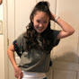
My daughter has watched too many makeup videos with me! Get Madison's favorite brushes , "I love it, you got to try it"!! http://www.sigmabeauty.com/?Click=26915

- Slide 20. Last step! Try out the mentor text activity described in slide 20 (and pasted below) and respond in the table (also below).
Note that the mentor text can be any genre, media and format. It can be part of a text – it could be an illustration in a picture book, or one brief excerpt from a video that you are familiar with, a print ad, a news report, etc. You decide! You might want to choose something that you could use with your own students (even third graders can participate in media literacy – I would probably choose 2 or 3 questions, and simplify the language so that it is age appropriate).

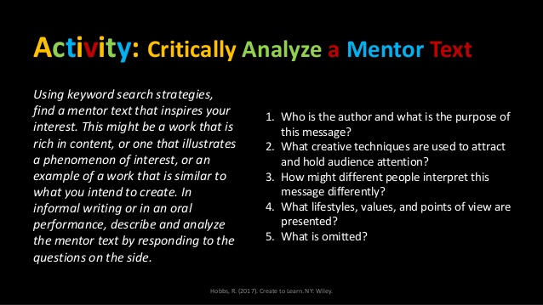

Complete the table, using your mentor text of interest!
Mentor text
Why did you choose this text?
What is it (genre and media)?
What is the source?
- Who is the author and what is the purpose of the message?
- What creative techniques are used to attract and hold audience attention?
- How might different people interpret this message?
- What lifestyles, values, and points of view are represented?
- What is omitted?
Anything else?

THE END

