YOUR NAME:

Create to Learn Companion Web Site
https://createtolearn.online/
- Go to the Create to Learn website and sign in.
- Click on tab, Student Study Materials
- Select the chapter that you are reading, and view the slide show. Follow your interests in relation to using other resources that are provided.

Reading Guide and Workshop Critical Reflection

Week 9: Chapters 9 and 10 (complete before class on 3/6)

Chapter 9 Images
After you read this chapter, please view the slide show on Images. The slideshow highlights key concepts such as verisimilitude, the truth, beauty and emotional valence of a photo, the rule of thirds, the power of editing, representational ethics, the relationship between image and headline or caption, etc.
Please complete the activity on slide 21, with three changes (see below). Then, respond to the reflection questions.
- 4 photos are fine (not 5).
- You do not need to post your photos online (although you may want to, and that is fine, too)! Instead, insert your images into the table below and add your headline or caption. Note that when you insert your image into the table, it may be too large. Grab the corner and resize it proportionately so that it fits. Then, select the photo and select middle alignment so that it is centered in the table box. We will view one another’s photos and respond next week.
- You may use some photos that you have taken previously with new photos taken this week (at least 2 of the 4 photos must be new). Have fun and play with this image experience!
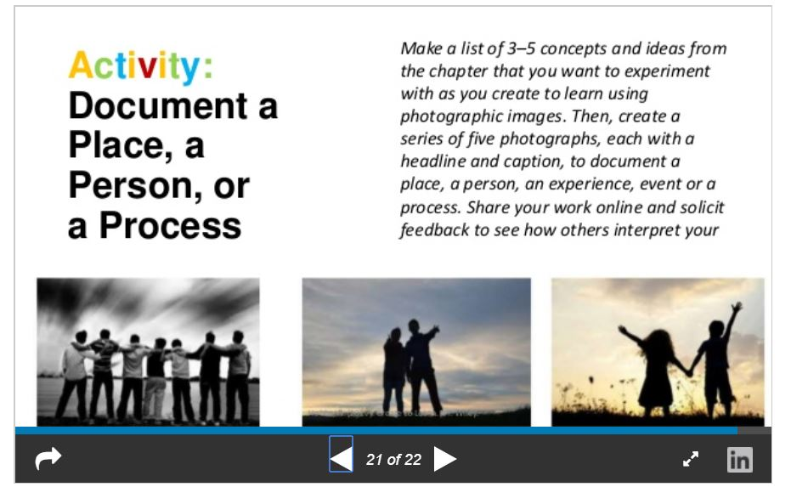

Name:
Photo 1
Headline or caption:
Photo 2
Headline or caption
Photo 3
Headline or caption:
Photo 4
Headline or caption:

- Image Activity Reflection
  - What did you discover about yourself as a creative person as you engaged in this activity?
  - How might you integrate the critical interpretation of photos and being a photographer (taking, editing, sharing) into your classroom?

Chapter 10 Infographics and Data Visualization
After you read this chapter, please view the slide show on Infographics and Data Visualization and respond to the three items below.
- Slide 17. Check out 2 of the infographic tools on this slide (picktochart, infogr.am, visualize.me, easel.ly).
Which tool might be useful to you (and your students)?
Why?
Is it free or low cost?
- Slide 23. 13 Reasons why your brain craves infographics. Click on the link in the slide, or use the following URL, to explore this infographic. https://neomam.com/interactive/13reasons/
What did you learn that you found compelling?
Surprising?
Disturbing?

- Slide 18. Find a ‘mentor text’ infographic online, in a magazine, etc. The chapter offers some sources; I enjoy the infographics in Wired magazine, National Geographic, New York Times, etc. You can also search on infographics in Google images and find a specific infographic that appeals to you.
If online, post the URL and image of the infographic into the table below. If in print, take a photo of the infographic and insert into the table, including your source. Bring the magazine with you to class (infographics often have very tiny print!). Below, briefly explain why you found this infographic powerful, considering the design and the content, and how they work together. If the digital infographic is interactive, explain how the interaction added to the experience (or detracted).
Name | Infographic source (URL, publication, etc.)
Infographic image
Analysis
- Emotional appeal
- Visual design (color, symbols, spatial layout, images, white space)
- Information (what did it help you learn, understand)?
- If interactive, how did the interactivity help you explore and learn about something of interest to you?
- How did the visual design and the written text work together to express meaning?

- After reading this chapter, do you plan to integrate infographics into your literacy instruction (as a critical consumer, a designer)? What might you try as a first step?

Observation Reflection on Tactile Picture Book Project that was held on 2/27 (due 3/6)
- Consider the overall experience (even if you were absent for a workshop!) and reflect on how this composition experience, using visual, tactile, sound, Braille, and written word modes, offered children new opportunities to express themselves, to be composer-designers. Provide examples. Then, consider how it introduced some challenges. Again, provide examples.
- Relate this to your own teaching context – what have you gained/learned from this experience that you might apply to your class? Might you do a version of a tactile composing project? If so, how would you change or customize it for your students?
- Collaborative retelling – how did this go for you and the children (or child) that you worked with? What worked, what might need change?
  - I worked with (name/s):
- Students’ sharing of work. What did you learn about students’ identities as composers, makers, communicators from their presentations? What interests were revealed? How might we expand an authentic audience for our workshop designers?
- 3 take-aways and 1 question:

THE END

