Create to Learn Companion Web Site
https://createtolearn.online/
- Go to the Create to Learn website and sign in.
- Click on tab, Student Study Materials
- Select the chapter that you are reading, and view the slide show. Follow your interests in relation to using other resources that are provided.

Reading Guide

Week 4: Chapter 3 (complete before class on 2/6)
Chapter 3 Decisions, Decisions
After reading the chapter, please view the Decisions, Decisions slide deck on the student resources section of the Create to Learn companion website .
Slides 5 and 6
View the two Dove video ads and then complete the chart below comparing the ads and the impact they had on you.
For each video, you can rate the ad from ‘beneficial’ to ‘harmful’ and compare your rating to others’ ratings. The chapter provides context information.
Video 1 http://propaganda.mediaeducationlab.com/rate/789
Video 2 http://propaganda.mediaeducationlab.com/rate/722
Please respond briefly to the following:

 | Dove Ad 1 (corporate) | Dove Ad 2 (Greenpeace)
- What was your reaction to this ad?
Consider the Author/business/organization
- Who is the target audience?
- What is the message?
What do they want their audience to
- Feel?

- Know?

- Do?

- What do they do to accomplish their goals (message).

Planning our Communications Strategy for sharing our work
Think about, mull over as you’re driving, taking a walk…
We want to share our work with others (Yes?1?). We are going to use the communications strategy framework presented in chapter 3 to explore options and develop a design approach. Do we want a blog? Post to Workbench (for making activities) or some other sharing site like instructibles?. Come to class prepared to discuss your ideas!
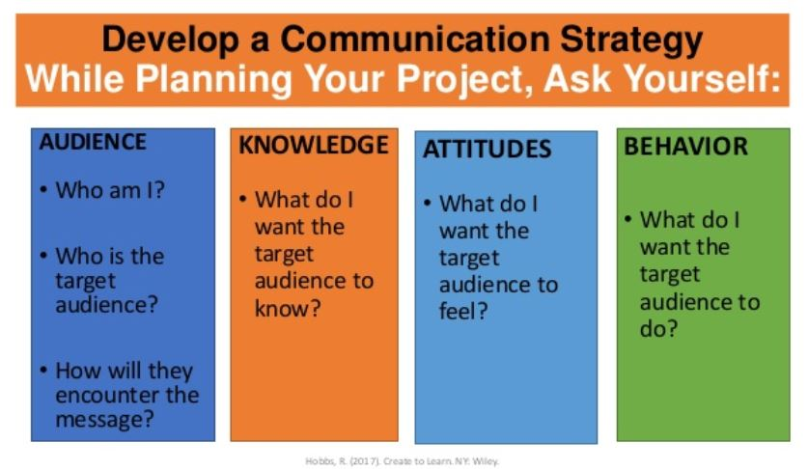
Hobbs, ch 3

